**<Classification of Car Exterior using an Image Classification Model>**

이태윤(Department of Art&Technology, 20231099)

The purpose of this experiment is to train and evaluate an image classification model to distinguish between the four different types of car exteriors, and to understand the visual elements that the model primarily considers in classifying car exteriors. Since obtaining my driver’s license this summer, I have developed a fondness for driving. As a result, I have been driving a lot and naturally developed an interest in cars, particularly in their exterior features such as color, size, and height. For this reason, I aimed to train and evaluate a classification model by categorizing cars into four types: sedan, SUV, van, and pickup truck, in order to delve deeper into understanding and distinguishing the various car exteriors. Before training the classification model, I contemplated the key visual characteristics of each category. Sedans are characterized by a smooth form and low chassis, SUVs have high ground clearance and large wheels, vans have high roofs and wide sliding doors, and pickup trucks have a roofless cargo space at the rear, namely a rear truck bed, and a high chassis. Therefore, in this experiment, it is anticipated that the model will primarily use the overall height of the chassis, the size of the wheels, and the presence of a rear truck bed as the main criteria for image classification.

Following that, I trained and evaluated a classification model without any pre-processing.

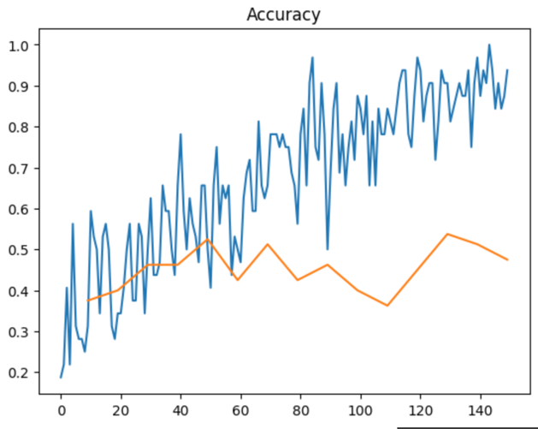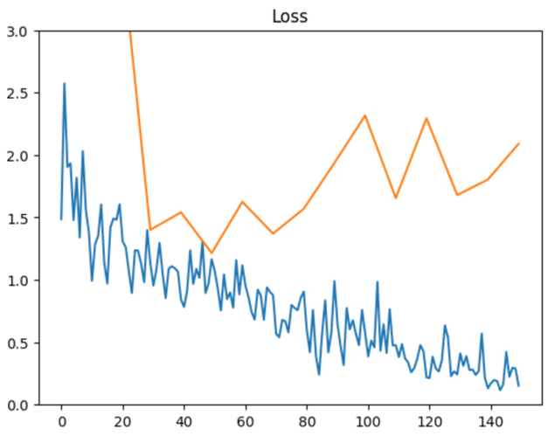

The image above depicts the accuracy on the training and test sets for the model. The blue graph, representing accuracy on the training set, increased steadily with training, reaching over 90 percent. In contrast, the orange graph, indicating accuracy on the test set, turned out to be lower than expected. The maximum accuracy was achieved at the 13th epoch, approximately 53 percent. The loss, unlike that in the training set, was also high. However, when training and evaluating a pre-trained model, one with prior experience or tasks performed, different results were obtained.

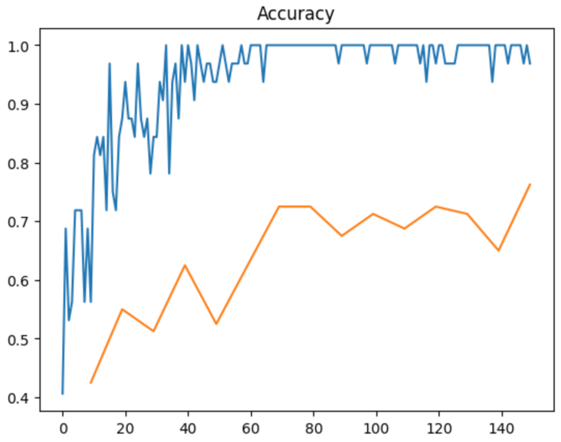

For a pre-trained model, the accuracy on the training set approached 100 percent, and on the test set, it reached a maximum accuracy of 76 percent at the 15th epoch. Despite neither model having prior experience with the task at hand, the model with pre-training experience showed an accuracy approximately 23 percent higher than the model without such pre-training. This observation led to the realization that pre-trained models tend to exhibit relatively superior performance compared to models without pre-training, regardless of specific training or occupation. Consequently, it became evident that utilizing pre-trained models more frequently is a favorable approach, and the methodology behind pre-training is considered effective. However, since both models were in their initial training stages, the classification patterns of the two models were remarkably similar. In other words, even in cases of misclassification, the reasons behind such occurrences did not exhibit significant differences.

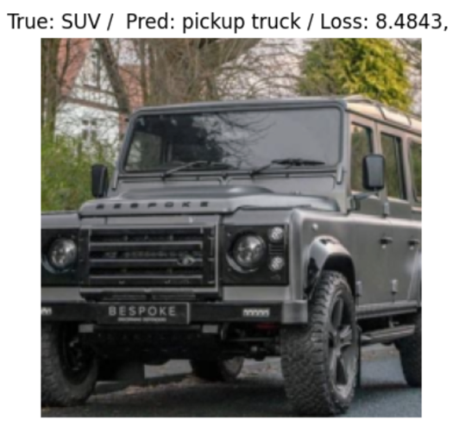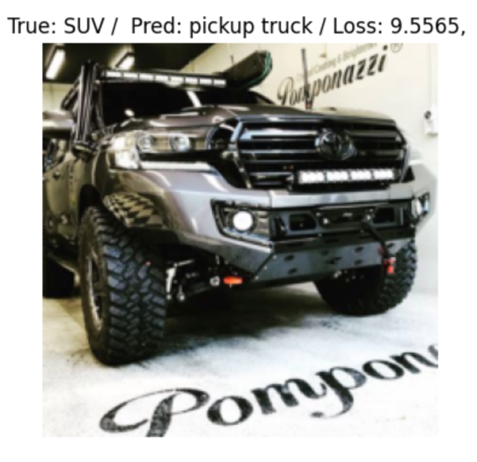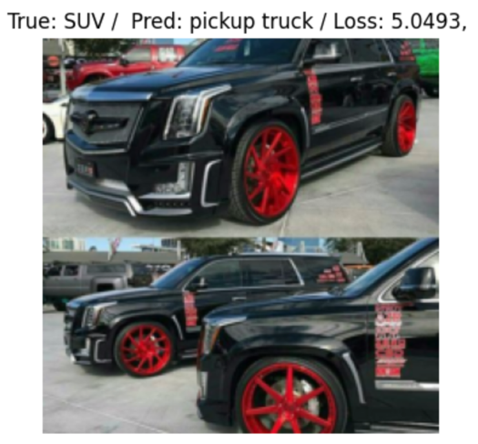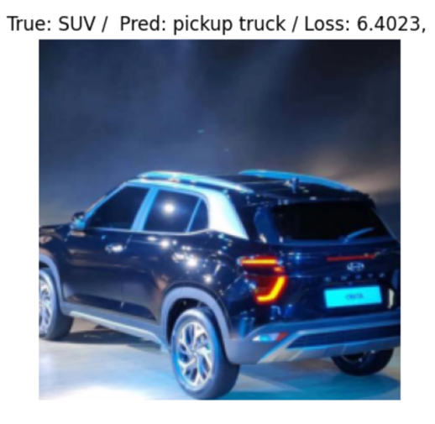

Firstly, the images above are predominantly those that the classification model primarily predicted as pickup trucks. Upon closer inspection of these images, each vehicle typically possesses large tires and an angular-shaped body, emphasizing prominent headlights and a sizable grille. Additionally, most of the vehicles exhibit a dark color scheme, predominantly black. From this, it can be inferred that the classification model relies on features such as tire size, body shape, headlight and grille dimensions, vehicle size, and color when making predictions for pickup trucks.

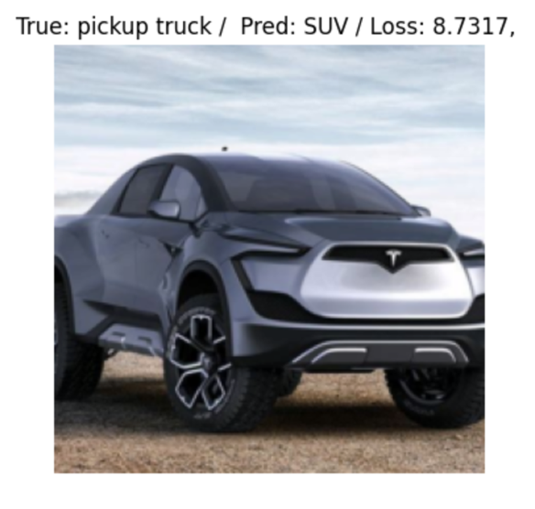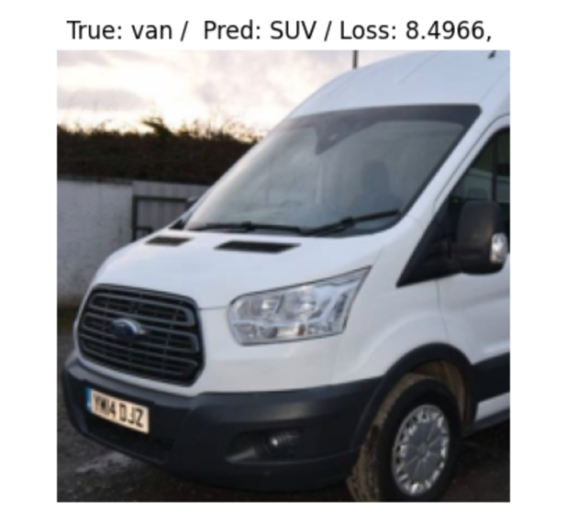

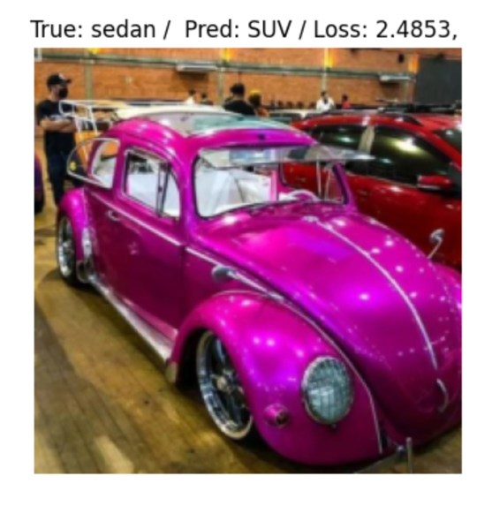

Next, the images above are those that the classification model categorized as SUV. Examining these images reveals that the vehicles share a commonality of having a smooth body shape and large size. Therefore, it can be understood that the classification model primarily utilizes features such as body shape and vehicle size when classifying images as SUV.

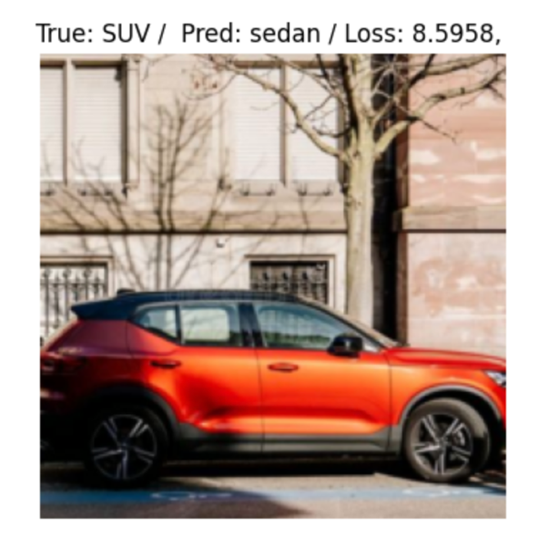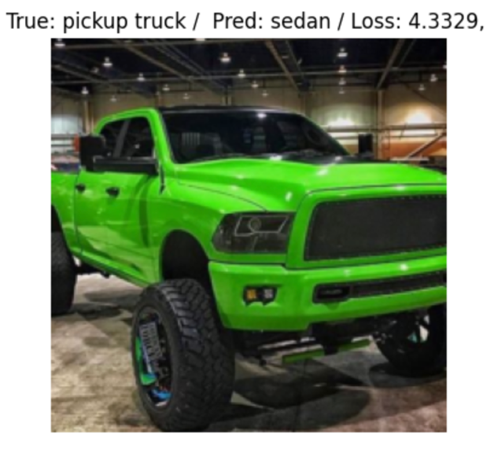

This time, the images are those that the classification model categorized as sedans. In the first image, despite being an SUV, the overall length of the car appears long, and the vehicle's height seems low. In the second image, despite being a typical pickup truck with a large grille, emphasized headlights, a tall body, and a large size, there is one distinct feature—the length of the vehicle appears long. Therefore, through this, it became evident that the classification model heavily relies on the length of the vehicle when classifying images as sedans. Additionally, it was observed that the height of the vehicle is also utilized in this classification.

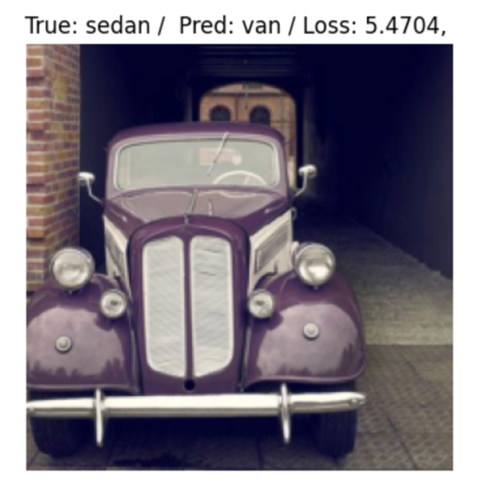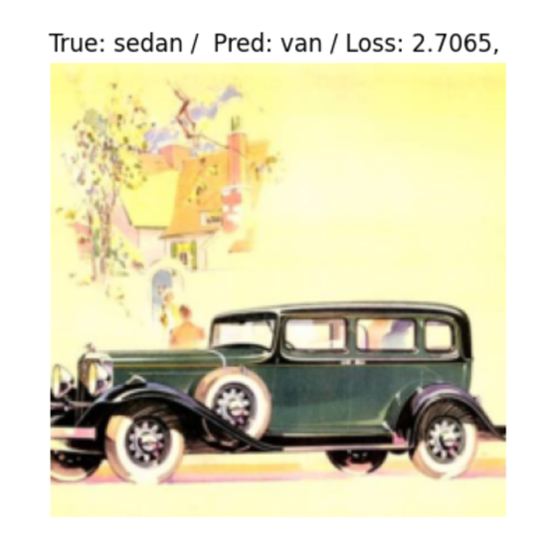

Finally, examining the images that the classification model identified as vans, in the first image depicting the front view of the vehicle, it appears elongated in the vertical direction. In the second image, from the body of the vehicle to the rear, the upper and lower surfaces seem parallel. Therefore, it can be deduced that the classification model utilizes the front view of the vehicle and the structure from the body to the rear when classifying images as vans. Overall, when reviewing the images that the model misclassified, it becomes apparent that the model utilizes various features, including the overall height and length of the vehicle, the shape and size of the body, the color of the vehicle, and features such as headlights, grille, and the front view of the vehicle, to classify images.

On the other hand, there were also many instances where inappropriate images for each category were present within the training and test datasets, adversely affecting the model's learning process.

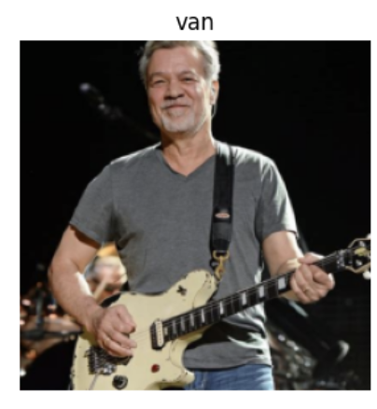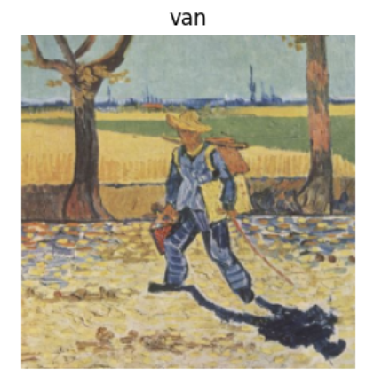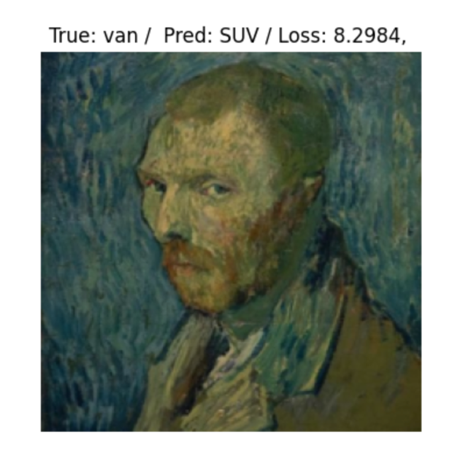

Similarly, there were numerous instances where images unrelated to automobiles, such as pictures of people, portraits, or artwork, were included in both the training and test datasets. Particularly, the inclusion of such images was notable in the van category, leading to the observation that the classification model did not properly learn the characteristics of images belonging to the van category.

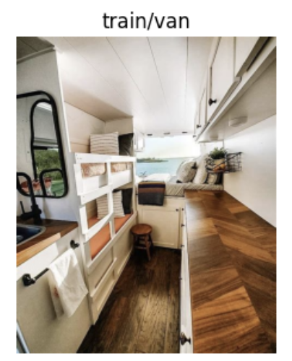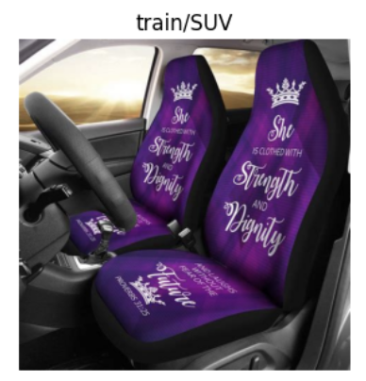

Additionally, as mentioned above, there were instances where images of the interior rather than the exterior of cars were included in the training and test datasets, causing confusion in the model's learning. Consequently, I decided to organize the training and test datasets and retrain the model. I retained only external images of vehicles overall, established consistent visual criteria for each category, and deleted images that did not meet these criteria. The visual criteria for each category were determined by referring to the model's image classification criteria learned from training and evaluation before data cleaning. Furthermore, regardless of category-specific criteria, images capturing a vehicle from excessively specific angles or only showing specific parts of the vehicle were removed to prevent the model from learning inaccurately. Images with poor quality that did not clearly depict the vehicle were also deleted for the same reason.

Regarding the specific visual criteria set for each category, for sedans, the criterion was a vehicle with an overall long and low body, and a slightly sloping hood. Images without a roof were excluded from the sedan category because sedans typically refer to cars with roofs. For SUVs, the criterion was an image of a vehicle with a smooth body shape and, at the same time, a large size. Pickup trucks were characterized by angular shapes, a tall body, an open cargo area at the rear with a lid or without a roof, and large tires. Lastly, for vans, the criterion was a vehicle with a short front section, i.e., a short hood, and an overall vertical elongation of the body. However, it's important to note that the van category had significantly fewer images in both the training and test datasets compared to other categories, as most images were unrelated to the vehicle's appearance.

After organizing the data in this manner, I retrained the model and conducted a thorough evaluation.

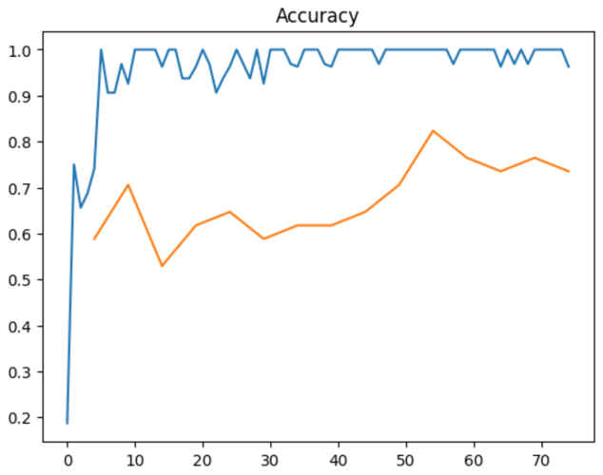

As seen in the above graph, the orange line representing accuracy on the test data is somewhat above. The accuracy on the training data is much closer to 100 percent than before, and for the test data, the maximum accuracy of 82 percent was achieved at the 11th epoch. While this accuracy is not extremely high, comparing it to the maximum test accuracy of 76 percent and 53 percent before organizing the data, it is evident that the data organization had a positive impact. Like the observations after training and evaluating the model before cleaning the data, I also examined instances where the model misclassified images in this iteration.

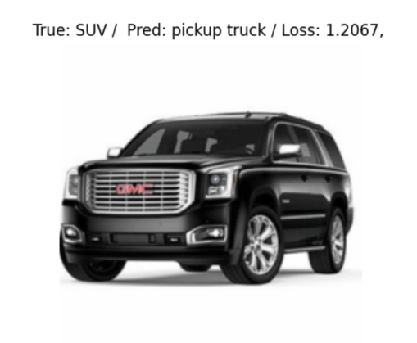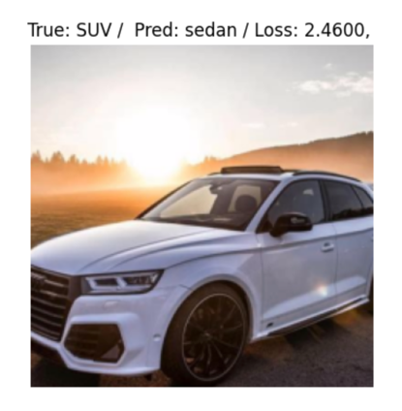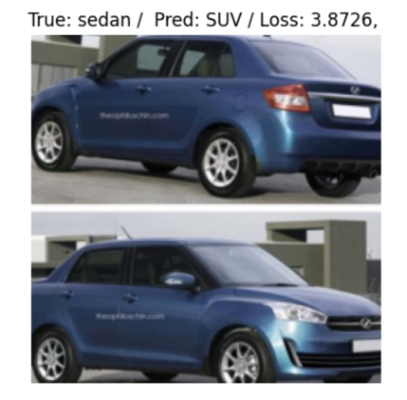

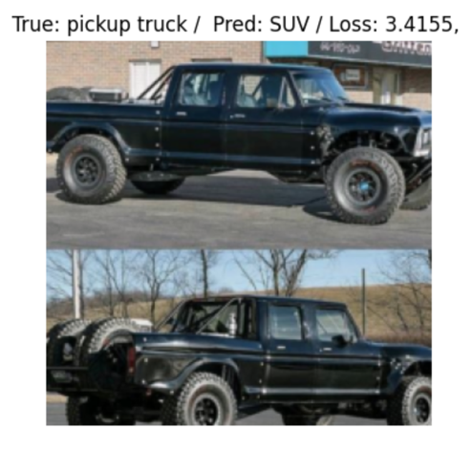

For the first image, the model classified it as a pickup truck likely due to the large grille and prominent headlights. In the case of the second image, the model recognized it as a sedan instead of an SUV likely because of the elongated appearance of the vehicle's hood. In the third image, the model identified it as an SUV, possibly due to the overall height of the vehicle. Lastly, for the last image, the model perceived it as an SUV, potentially influenced by the apparent size of the tires and the larger gap between the vehicle's underside and the ground. Through these observations, I hypothesized that the model relies on five key criteria when classifying images: the size of the grille and headlights, the length of the vehicle's hood, the overall height of the vehicle, and the size of the tires. To validate this hypothesis, I downloaded several images directly from the internet and conducted tests on the model.

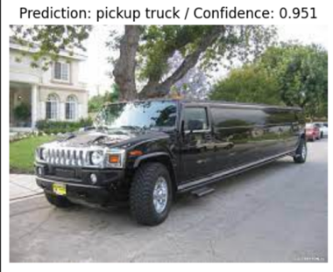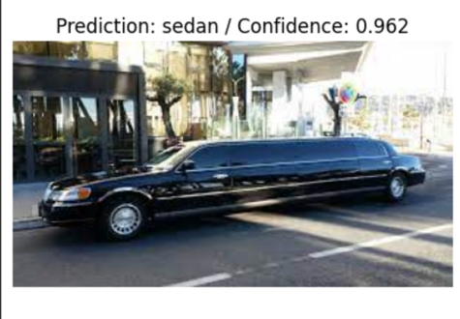

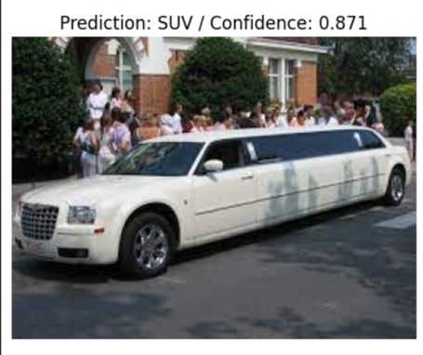

Firstly, I downloaded three images of long vehicles and conducted tests. Despite all three images featuring long vehicles, the model classified them differently. Upon closer inspection of the images classified as a pickup truck and an SUV, it became apparent that the size and shape of the grille, as well as the structure of the headlights, differed. Furthermore, in contrast to the other two images, the image classified by the model as a sedan showed an elongated hood. Through this, it was possible to demonstrate that the classification model considers the length of the vehicle's hood, the size and shape of the grille, and the structure of the headlights as crucial criteria for image classification.

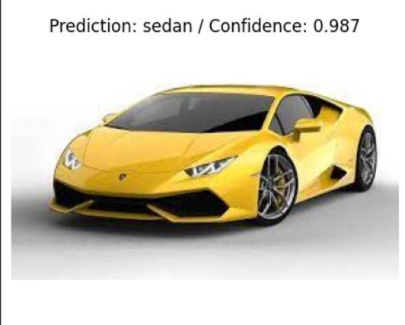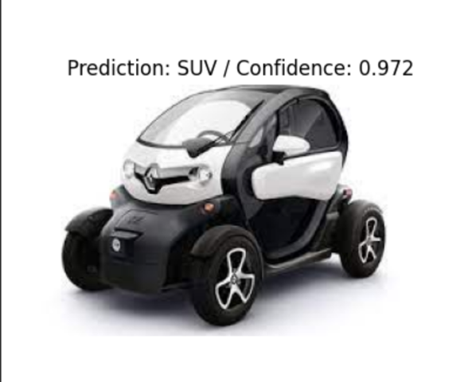

Next, I downloaded images of vehicles with varying overall heights and conducted tests. The classification model assigned different categories to the two images, demonstrating that the overall height of the vehicle is a crucial criterion in the model's image classification.

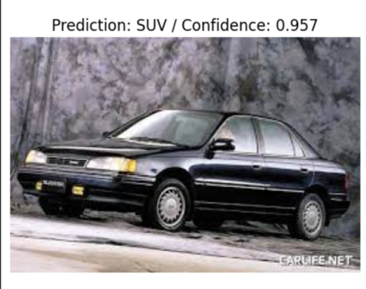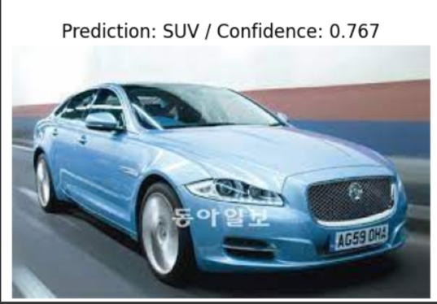

Finally, I downloaded images of two sedans with different tire sizes to conduct tests. According to my hypothesis, which considered tire size as an important criterion for the model's classification, I expected the model to classify them differently. Contrary to my expectations, the model classified both images into the same category. Consequently, I realized that contrary to my initial hypothesis, the size of the vehicle's tires is not a crucial criterion in the model's image classification. Through these additional tests using images downloaded from the internet, it became evident that the key criteria in the model's image classification are the size and shape of the grille and headlights, the length of the vehicle's hood, and the overall height of the vehicle.

Through this experiment, I trained and evaluated an image classification model to distinguish between four different car body types, aiming to understand the visual elements the model primarily considers during image classification. Initially, the model exhibited low accuracy on the test data, but after organizing the data and retraining, its performance improved.

Before data cleaning, the model classified images of vehicles with large tires, angular body shapes, emphasized headlights and grilles, and dark colors as pickup trucks. Images of vehicles with smooth body shapes and large sizes were classified as SUVs, while images of vehicles with low overall height and long length were classified as sedans. Images of vehicles with a vertical orientation, where the upper and lower sides from the front to the rear were parallel, were classified as vans. After cleaning the data and retraining the model, a hypothesis was formulated that the model classifies images based on the size of the grille and headlights, the length of the hood, the overall height of the vehicle, and the size of the tires. To validate this hypothesis, additional images downloaded from the internet were tested. The results indicated that tire size was not a significant classification criterion, while the size and shape of the grille and headlights, the length of the hood, and the overall height of the vehicle were crucial classification criteria.

Additionally, before data cleaning, I trained and compared models, one pretrained and one not pretrained. While the image classification patterns of the two models were similar, the pretrained model exhibited higher accuracy than the non-pretrained model. These results suggest that pretrained models can perform well in image classification tasks, emphasizing the importance of data refinement and using pre-trained model in future research and applications. The insights gained from this experiment are expected to serve as valuable guidelines for improving the performance of image classification models.